Equal Region Containment

Definition
# Source: AI Source: Provided by: [Data Path: Persons Table -> ID Column: 1, Name_En Column: Motasem Essam] -> From: [ChatGPT] on [7/25/2026]
Equal Region Containment describes the case where two geometric regions contain exactly the same set of points.
Mathematically, if regions $R_{1}$and $R_{2}$are equal:
$$\boxed{R_{1}=R_{2}}$$
This means every point belonging to $R_{1}$also belongs to $R_{2}$, and every point belonging to $R_{2}$also belongs to $R_{1}$.
Formally:
$$\boxed{R_{1}=R_{2} ⟺ R_{1}⊆R_{2}\text{ and }R_{2}⊆R_{1}}$$
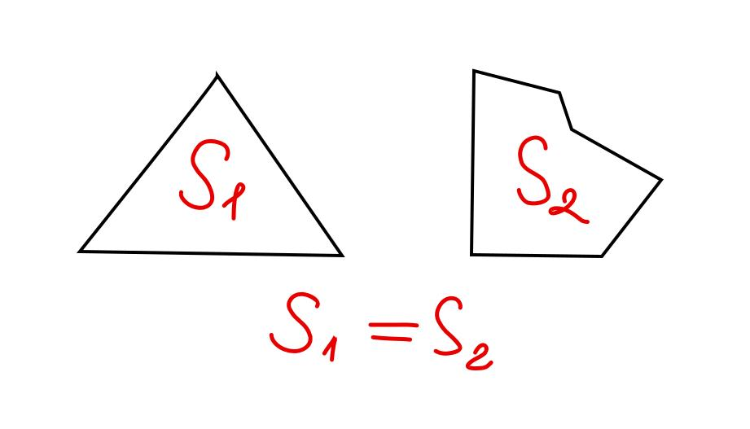

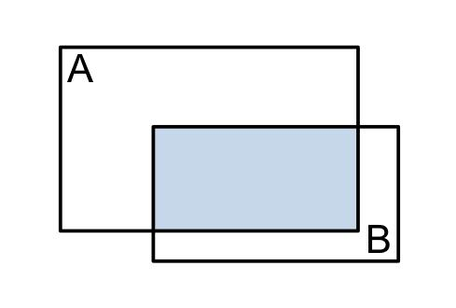

Purpose
# Source: AI Source: Provided by: [Data Path: Persons Table -> ID Column: 1, Name_En Column: Motasem Essam] -> From: [ChatGPT] on [7/25/2026]
Equal Region Containment is used to determine whether two regions occupy exactly the same geometric location and extent.
It distinguishes:
- equal regions,
- proper containment,
- partial overlap,
- boundary-touching containment,
- and disjoint regions.

Fundamental Concept
# Source: AI Source: Provided by: [Data Path: Persons Table -> ID Column: 1, Name_En Column: Motasem Essam] -> From: [ChatGPT] on [7/25/2026]
A geometric region can be considered a set of points.
Therefore, two regions are equal when their point sets are identical:
$$\boxed{R_{1}=R_{2}}$$
There cannot be a point that belongs to one region but not the other.
Thus:
$$\boxed{R_{1}∖R_{2}=∅}$$
and:
$$\boxed{R_{2}∖R_{1}=∅}$$

Mathematical Representation
# Source: AI Source: Provided by: [Data Path: Persons Table -> ID Column: 1, Name_En Column: Motasem Essam] -> From: [ChatGPT] on [7/25/2026]
The most important representation is:
$$\boxed{R_{1}=R_{2}}$$
Equivalent set-containment representation:
$$\boxed{R_{1}⊆R_{2} \text{and} R_{2}⊆R_{1}}$$
Pointwise:
$$\boxed{P∈R_{1} ⟺ P∈R_{2}}$$
for every point $P$.
This means:
A point belongs to $R_{1}$if and only if it belongs to $R_{2}$.

Fundamental Elements
# Source: AI Source: Provided by: [Data Path: Persons Table -> ID Column: 1, Name_En Column: Motasem Essam] -> From: [ChatGPT] on [7/25/2026]
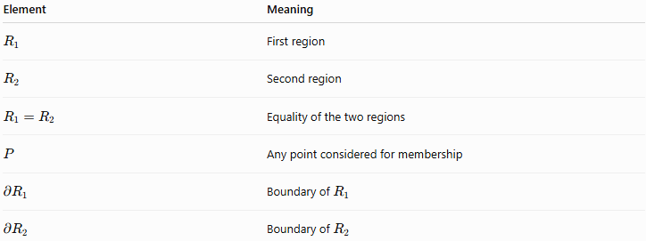
Element | Meaning
$$R_{1}$$ | First region
$$R_{2}$$ | Second region
$$R_{1}=R_{2}$$ | Equality of the two regions
$$P$$ | Any point considered for membership
$$∂R_{1}$$ | Boundary of $R_{1}$
$$∂R_{2}$$ | Boundary of $R_{2}$
For equal regions:
$$\boxed{∂R_{1}=∂R_{2}}$$
and:
$$\boxed{int⁡\left(R_{1}\right)=int⁡\left(R_{2}\right)}$$
when the regions are regarded as the same point set.

Examples

Example 1 – Two Identical Disks
# Source: AI Source: Provided by: [Data Path: Persons Table -> ID Column: 1, Name_En Column: Motasem Essam] -> From: [ChatGPT] on [7/25/2026]
Consider:
$$R_{1}=\left\{\left(x , y\right)∣x^{2}+y^{2}≤25\right\}$$
and:
$$R_{2}=\left\{\left(x , y\right)∣x^{2}+y^{2}≤25\right\}$$
Both describe the same disk with center $\left(0 , 0\right)$and radius $5$.
Therefore:
$$\boxed{R_{1}=R_{2}}$$

Example 2 – Same Region, Different Equations
# Source: AI Source: Provided by: [Data Path: Persons Table -> ID Column: 1, Name_En Column: Motasem Essam] -> From: [ChatGPT] on [7/25/2026]
Consider:
$$R_{1}=\left\{\left(x , y\right)∣x^{2}+y^{2}≤25\right\}$$
and:
$$R_{2}=\left\{\left(x , y\right)∣{\left(x-0\right)}^{2}+{\left(y-0\right)}^{2}≤5^{2}\right\}$$
Although their equations look different, they describe exactly the same set of points.
Therefore:
$$\boxed{R_{1}=R_{2}}$$
This demonstrates an important principle:
Different mathematical descriptions can represent the same geometric region.

Example 3 – Identical Rectangular Regions
# Source: AI Source: Provided by: [Data Path: Persons Table -> ID Column: 1, Name_En Column: Motasem Essam] -> From: [ChatGPT] on [7/25/2026]
Suppose:
$$R_{1}=\left\{\left(x , y\right) , ∣0≤x≤8 0≤y≤5\right\}$$
and:
$$R_{2}=\left\{\left(x , y\right) , ∣x∈\left[0 , 8\right] y∈\left[0 , 5\right]\right\}$$
Then:
$$\boxed{R_{1}=R_{2}}$$
because both descriptions specify exactly the same rectangle.

Equal Regions and Coincidence
# Source: AI Source: Provided by: [Data Path: Persons Table -> ID Column: 1, Name_En Column: Motasem Essam] -> From: [ChatGPT] on [7/25/2026]
For regions, equality is closely related to coincidence.
If two geometric regions occupy exactly the same set of points, they are equal:
$$\boxed{R_{1}=R_{2}}$$
For example, if two circular regions have the same center and radius, they occupy the same points.
However, equal and congruent are not the same concept.

Equal vs Congruent Regions
# Source: AI Source: Provided by: [Data Path: Persons Table -> ID Column: 1, Name_En Column: Motasem Essam] -> From: [ChatGPT] on [7/25/2026]
Two regions can have the same shape and size but occupy different locations.
For example, two identical circles can be congruent:
$$R_{1}≅R_{2}$$
without being equal as sets:
$$R_{1}≠R_{2}$$
If they are moved to different locations, they are still congruent but no longer equal.
Example
Circle 1:
$${\left(x-2\right)}^{2}+y^{2}≤9$$
Circle 2:
$${\left(x-10\right)}^{2}+y^{2}≤9$$
Both have radius $3$, so they are congruent, but:
$$\boxed{R_{1}≠R_{2}}$$
because they occupy different locations.

Equal vs Properly Contained Regions
# Source: AI Source: Provided by: [Data Path: Persons Table -> ID Column: 1, Name_En Column: Motasem Essam] -> From: [ChatGPT] on [7/25/2026]
Proper containment requires the regions to be different:
$$R_{1}⊊R_{2}$$
Equal regions satisfy:
$$R_{1}=R_{2}$$
Therefore:
$$\boxed{R_{1}=R_{2} \text{and} R_{1}⊊R_{2}}$$
cannot both be true.
However, equal regions satisfy ordinary containment:
$$\boxed{R_{1}⊆R_{2}}$$
and:
$$\boxed{R_{2}⊆R_{1}}$$
simultaneously.

Equal Region vs Overlapping Regions
# Source: AI Source: Provided by: [Data Path: Persons Table -> ID Column: 1, Name_En Column: Motasem Essam] -> From: [ChatGPT] on [7/25/2026]
Two regions overlap when they share at least one point:
$$R_{1}∩R_{2}≠∅$$
Equal regions certainly overlap:
$$R_{1}=R_{2}⇒R_{1}∩R_{2}=R_{1}=R_{2}$$
However, ordinary overlap does not imply equality.
For example, two partially overlapping circles satisfy:
$$R_{1}∩R_{2}≠∅$$
but:
$$R_{1}≠R_{2}$$

Equal Region vs Disjoint Regions
# Source: AI Source: Provided by: [Data Path: Persons Table -> ID Column: 1, Name_En Column: Motasem Essam] -> From: [ChatGPT] on [7/25/2026]
Disjoint regions have no common points:
$$\boxed{R_{1}∩R_{2}=∅}$$
Equal nonempty regions cannot be disjoint because:
$$R_{1}=R_{2}$$
Therefore:
$$R_{1}∩R_{2}=R_{1}$$
If the region is nonempty, the intersection is also nonempty.

Properties of Equal Region Containment

1. Reflexive
# Source: AI Source: Provided by: [Data Path: Persons Table -> ID Column: 1, Name_En Column: Motasem Essam] -> From: [ChatGPT] on [7/25/2026]
Every region is equal to itself:
$$\boxed{R=R}$$

2. Symmetric
# Source: AI Source: Provided by: [Data Path: Persons Table -> ID Column: 1, Name_En Column: Motasem Essam] -> From: [ChatGPT] on [7/25/2026]
If:
$$R_{1}=R_{2}$$
then:
$$\boxed{R_{2}=R_{1}}$$

3. Transitive
# Source: AI Source: Provided by: [Data Path: Persons Table -> ID Column: 1, Name_En Column: Motasem Essam] -> From: [ChatGPT] on [7/25/2026]
If:
$$R_{1}=R_{2}$$
and:
$$R_{2}=R_{3}$$
then:
$$\boxed{R_{1}=R_{3}}$$

4. Mutual Containment
# Source: AI Source: Provided by: [Data Path: Persons Table -> ID Column: 1, Name_En Column: Motasem Essam] -> From: [ChatGPT] on [7/25/2026]
Equality can be established through mutual containment:
$$\boxed{R_{1}⊆R_{2}\text{ and }R_{2}⊆R_{1}}$$
therefore:
$$\boxed{R_{1}=R_{2}}$$
This is one of the most important ways to prove equality between geometric regions.

5. Equal Regions Have Equal Area
# Source: AI Source: Provided by: [Data Path: Persons Table -> ID Column: 1, Name_En Column: Motasem Essam] -> From: [ChatGPT] on [7/25/2026]
For finite planar regions:
$$\boxed{R_{1}=R_{2}⇒A\left(R_{1}\right)=A\left(R_{2}\right)}$$
where $A\left(R\right)$represents area.

6. Equal 3D Regions Have Equal Volume
# Source: AI Source: Provided by: [Data Path: Persons Table -> ID Column: 1, Name_En Column: Motasem Essam] -> From: [ChatGPT] on [7/25/2026]
For finite three-dimensional regions:
$$\boxed{R_{1}=R_{2}⇒V\left(R_{1}\right)=V\left(R_{2}\right)}$$
where $V\left(R\right)$represents volume.

Equality of Boundaries and Interiors
# Source: AI Source: Provided by: [Data Path: Persons Table -> ID Column: 1, Name_En Column: Motasem Essam] -> From: [ChatGPT] on [7/25/2026]
If:
$$R_{1}=R_{2}$$
then their corresponding geometric components are identical:
$$\boxed{int⁡\left(R_{1}\right)=int⁡\left(R_{2}\right)}$$
and:
$$\boxed{∂R_{1}=∂R_{2}}$$
Thus, there is no geometric portion of one region that lies outside the other.

Comparison of Region Containment Types
# Source: AI Source: Provided by: [Data Path: Persons Table -> ID Column: 1, Name_En Column: Motasem Essam] -> From: [ChatGPT] on [7/25/2026]
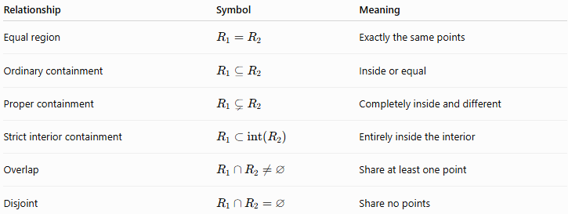
Relationship | Symbol | Meaning
Equal region | $$R_{1}=R_{2}$$ | Exactly the same points
Ordinary containment | $$R_{1}⊆R_{2}$$ | Inside or equal
Proper containment | $$R_{1}⊊R_{2}$$ | Completely inside and different
Strict interior containment | $$R_{1}⊂int⁡\left(R_{2}\right)$$ | Entirely inside the interior
Overlap | $$R_{1}∩R_{2}≠∅$$ | Share at least one point
Disjoint | $$R_{1}∩R_{2}=∅$$ | Share no points

Relationship with Related Concepts
# Source: AI Source: Provided by: [Data Path: Persons Table -> ID Column: 1, Name_En Column: Motasem Essam] -> From: [ChatGPT] on [7/25/2026]
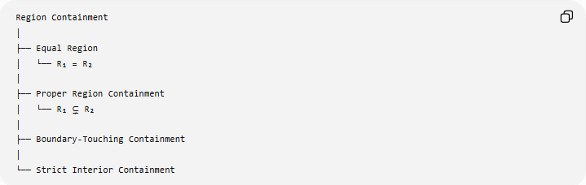
Region Containment
│
├── Equal Region
│ └── R₁ = R₂
│
├── Proper Region Containment
│ └── R₁ ⊊ R₂
│
├── Boundary-Touching Containment
│
└── Strict Interior Containment
Important: Equal Region Containment is technically better described as Region Equality rather than a true proper containment relationship, because proper containment specifically requires a strict subset.

Real-World Applications
# Source: AI Source: Provided by: [Data Path: Persons Table -> ID Column: 1, Name_En Column: Motasem Essam] -> From: [ChatGPT] on [7/25/2026]
- Cartography: two region datasets may represent exactly the same geographic area.
- GIS: two polygon layers may have identical boundaries and interiors.
- CAD: two modeled regions may occupy exactly the same space.
- Computer graphics: two masks may cover exactly the same pixels.
- Architecture: two floor-plan regions may describe the same physical area.
- Engineering: two defined operating regions may have identical spatial boundaries.

Key Points
# Source: AI Source: Provided by: [Data Path: Persons Table -> ID Column: 1, Name_En Column: Motasem Essam] -> From: [ChatGPT] on [7/25/2026]
- Equal regions contain exactly the same points.
- The notation is:
$$\boxed{R_{1}=R_{2}}$$
- Equality is equivalent to mutual containment:
$$\boxed{R_{1}⊆R_{2}\text{ and }R_{2}⊆R_{1}}$$
- Equal regions are not properly contained in one another.
- Equal regions may be congruent, but congruent regions do not have to be equal.
- Equal regions have the same boundaries, interiors, area, and—when applicable—volume.
- For precise taxonomy, Equal Regions is better classified under Equality/Coincidence than under proper containment.

Conclusion
# Source: AI Source: Provided by: [Data Path: Persons Table -> ID Column: 1, Name_En Column: Motasem Essam] -> From: [ChatGPT] on [7/25/2026]
Equal Region Containment occurs when two regions are identical as sets of points:
$$\boxed{R_{1}=R_{2}}$$
Although equality can be expressed through mutual containment, it should be distinguished from proper region containment, because proper containment requires:
$$R_{1}≠R_{2}$$
Thus, in a rigorous geometry knowledge base, Equal Regions should be treated primarily as a form of geometric equality/coincidence, while Proper Region Containment remains a strict subset relationship.

